Painting Supplies List |Open Ground Studios
Instructor: Robert Burcar | robertburcar@gmail.com

Italics are for recommended brands
* denotes community supplies OGS has available if you do not want to buy your own

Paper/Canvas
- 9 x 12 or 11 x14 Sketch pad (64lb or less) example: Strathmore 400 series: acid free* optional
- 11”x 14” Canvas Boards or Pre Stretched Canvas (1-2)

Paint
- Acrylic Paints- Tube (not bottled craft paint) Nice quality brands: Liquitex Heavy Body, Liquitex Basic or Utrecht
- Required Colors: Titanium White, Yellow Ocre or Yellow Oxide, Ultramarine Blue, Alizarin Crimson, Burnt Umber
- Optional Colors: Red Oxide, Burnt Sienna
OGS has student grade acrylic paints and paintbrushes that may be used during the first couple of sessions. If budgetary constraint makes it a hardship for students to purchase all colors/brushes, OGS is happy to supplement as needed.

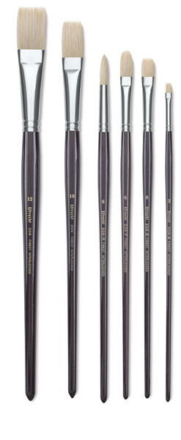
Note: Liquitex basic paints are inexpensive and economical. While they are workable, they tend to be much more fluid and as a result can be difficult to create thick texture on canvas. Michaels and Aaron Brothers have a nice selection and variety of acrylic paints.

Paintbrushes
- #10 flat
- #6 Round
- #6 flat
Only three brushes are needed. I recommend natural pure bristle or white hog bristle. One of my favorite brushes is Utrecht Natural Chungking pure bristle. There are many brands out there but my recommended three are Princeton, Winsor and Newton and Utrecht Natural Chungking. Each brush runs approx $10-15 each. You can get these brushes on utrecht.com or dickblick.com. Below is a photo of what these brushes look like.

Drawing
- *Sketching Pencil-Example Derwent or Faber Castell Graphite HB Sketching Pencil.
- *Eraser- I prefer the kneading erasers

MISC
- A rectangular plastic painting palette large enough to mix colors on, approx 8 x 10.
No round well palettes. Disposable palette paper pads can also be used.
- Laptop to look up reference photos-if student has one
- 1- 3 photo references of the subject to use for painting project. Either on laptop or hard copy. Photographs will be discussed and looked through on first day of class so it's a good idea to bring ones you are considering using for your reference. Tip: strong lighting and shadow: one light source.
- *1 small spray bottle

Optional for home use
- *1 roll of paper towels for creating palette and wiping brushes
- *Saral Transfer Paper
- Neutral Gray Gesso-example Liquitex Basics Acrylic Gesso
- *Large jar or coffee can for water
- Tiny plastic paint containers with air tight lids to save unused paint (optional)

